Distance Detecting

Designed an Arduino to detect the distance with US senson and displaying eith the help of &bit comparator;

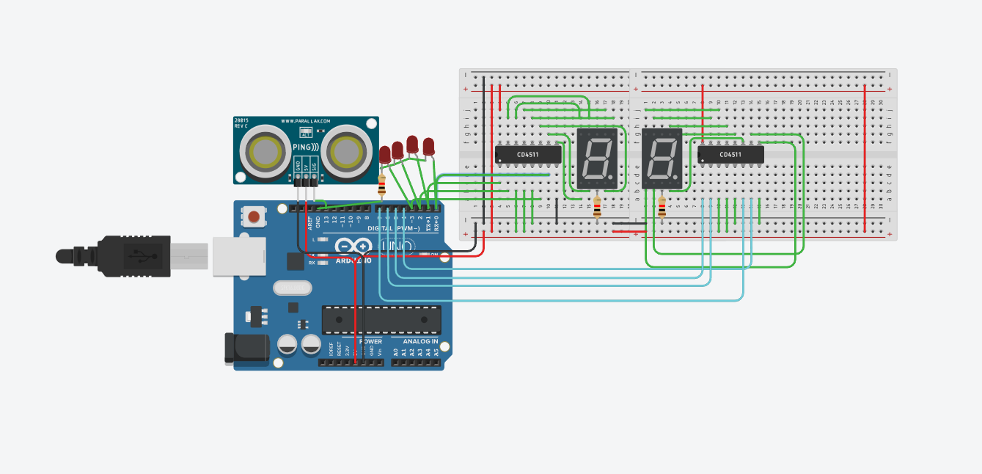

Code:

long readUltrasonicDistance(int triggerPin, int echoPin)

{

pinMode(triggerPin, OUTPUT); // Clear the trigger

digitalWrite(triggerPin, LOW);

delayMicroseconds(2);

// Sets the trigger pin to HIGH state for 10 microseconds

digitalWrite(triggerPin, HIGH);

delayMicroseconds(10);

digitalWrite(triggerPin, LOW);

pinMode(echoPin, INPUT);

// Reads the echo pin, and returns the sound wave travel time in microseconds

return pulseIn(echoPin, HIGH);

}

void setup()

{ for(int i=0;i<8;i++)

pinMode(i, OUTPUT); // D0

}

void loop()

{

int cm = 0.01723 \* readUltrasonicDistance(13,13);

int inches = (cm /2.54);Serial.print(inches);

Serial.print(F("Hello World"));

Serial.println(cm);

//for(int j=0;j<99;j++)

{ //inches=j;

if((inches%10)<7){

if((inches%10)%2!=0)digitalWrite(4,HIGH);

if((inches%10)%4>1)digitalWrite(5,HIGH);

if((inches%10)%8>3)digitalWrite(6,HIGH);

}

else{

if((inches%10)>8)digitalWrite(4,HIGH);

digitalWrite(7,HIGH);

}

if(((inches/10)%10)<7){

if(((inches/10)%10)%2!=0)digitalWrite(0,HIGH);

if(((inches/10)%10)%4>1)digitalWrite(1,HIGH);

if(((inches/10)%10)%8>3)digitalWrite(2,HIGH);

}

else{

if(((inches/10)%10)>8)digitalWrite(0,HIGH);

digitalWrite(3,HIGH);

}

delay(500);

for(int i=0;i<8;i++)

digitalWrite(i,LOW);

}

}